|  |  |  |  |
| --- | --- | --- | --- |
| **Document Revision History** | | | |
| Revision | Date | By | Remarks |
| A1 | 12/13/2019 |  | Created. |

1 High Level Business Requirement 2

2 Business Units Using the Report 2

3 Sample Layout 2

4 IFS Permissions 3

5 Fields Specification 3

6 Other Considerations/ Notes 3

# High Level Business Requirement

Add two (2) new columns to Transport Task Lines screen:

Create Date

Execute Date

# Business Units Using the Functionality

Mark the plant(s) that will be using the report. Multiple can be checked.

|  |  |
| --- | --- |
| Inventory Management | X |
|  |  |
|  |  |

# Sample Layout

Transport Task ID 4 is being used (in DEV) to render these new values.

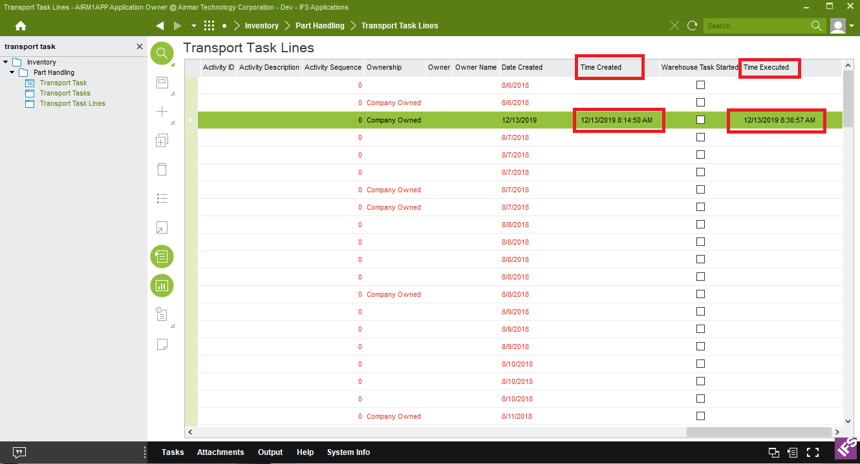

# IFS Permissions

User will need to add new properties to their screen view

# Fields Specification

|  |  |  |  |  |
| --- | --- | --- | --- | --- |
| **Section** | **Name** | **Description** | **IFS Screen** | **Format** |
|  | Time Created | N/A | Transport Task Lines | Date/ Time Stamp |
|  | Time Executed | N/A | Transport Task Lines | Date/ Time Stamp |
|  |  |  |  |  |
|  |  |  |  |  |
|  |  |  |  |  |
|  |  |  |  |  |
|  |  |  |  |  |
|  |  |  |  |  |
|  |  |  |  |  |
|  |  |  |  |  |
|  |  |  |  |  |
|  |  |  |  |  |
|  |  |  |  | |

# Other Considerations/ Notes

Application Configuration Package: WO-8686-TransportTaskLine

